

<Maverick Dress>

Documentation

Authors | A2409G – Group 3
HA THANH VU
NGUYEN THANH TAM
PHAM TIEN DAT
LE NHAT MINH
Date | 26/09/2025
Instructor | TO HOANG ANH

Hanoi, 2025
Index
Executive Summary 4
Acknowledgement 5
Introduction 6
Problem Definition 8
Problem Abstraction 8
The Current System 9
The Proposed System 9
Key Features of the Proposed System: 10
I. Home pages Design 10
II. Navigation & Product Categories 10
III. Product Search & Filtering 10
IV. Fashion Gallery & Collections 10
V. Customer Feedback & Contact Information 10
VI. Role-Based Dashboards 10
VII. Additional Functionalities for Enhanced User Experience 11
Boundaries of the System 11
I. Target Users 11
II. Scope of the System 12
Offered Keys Featured: 14
Platform Limitations 15
III. System Limitations 15
Hardware and Software Requirements 16
Hardware Requirements 16
Server (Hosting Requirements): 16
Client (User Devices): 16
Software Requirements 16
Technologies Used: 16
Frontend: 16
Backend: 17
Database: 17
Development Tools: 17
Testing & Debugging Tools: 17
Device Simulation & Browser Testing: 17
Other Requirements: 17
Customer Requirements Specification 17
Users Of the System 17
System Function 18
Systems Designs 20
Entity Relationship Diagram 20
Database Design 22
Detailed Table Descriptions 23
Sitemap 26
Site Map Overview 26
Textual Site Map 27
2. Page Interactions and Navigation Flow 28
Conclusion 32
Project research phase 33
System design phase 33
UI/UX design phase 33
Development phase 33
Testing phase 33
Deployment phase 33
Task Sheet 34
1. Phase-by-Phase Breakdown 34
2. Analysis and Insights 36
Conclusion 37

Executive Summary

The Maverick Dresses project is an academic initiative undertaken by a group of students at Aptech — Ha Thanh Vu, Nguyen Thanh Tam, Pham Tien Dat, and Le Nhat Minh — developed between August 27, 2025, and September 26, 2025 under the supervision of Mr. To Hoang Anh. The project’s primary objective is to design and implement a modern e-commerce platform for Maverick, a company specializing in uniforms and apparel manufacturing.
In an era where digital transformation is reshaping industries, the retail and fashion sectors are rapidly moving online. Maverick, which traditionally relied on physical stores and manual operations, faced limitations in customer reach, order processing, and scalability. The Maverick Dresses project addresses these challenges by building a web-based solution that provides customers with an intuitive, visually appealing, and responsive shopping experience.
The platform incorporates essential e-commerce functionalities, including product categorization, search and filtering, shopping cart and checkout operations, order management, and customer feedback. To enhance administrative efficiency, role-based dashboards are integrated, allowing administrators to manage users and security, while managers oversee products, categories, orders, and promotional content.
From a technical perspective, the project employs Laravel 12.x with MySQL for backend services and React 19.x with Bootstrap for frontend development. This separation of concerns ensures maintainability, scalability, and cross-browser compatibility across Chrome, Edge, and Firefox. Additional features such as a gallery of seasonal collections, responsive layouts, and secure authentication with JWT tokens further strengthen the system’s usability and reliability.
Beyond technical implementation, the project highlights the team’s ability to apply theoretical knowledge in software engineering to a real-world scenario. Over the course of one month, the team collaborated through distinct phases: requirement gathering, feasibility study, database and API design, frontend and backend development, testing, and final deployment. Each phase contributed to a robust outcome that not only satisfies functional requirements but also demonstrates best practices in teamwork, project planning, and quality assurance.
Overall, the Maverick Dresses project successfully delivers a functional prototype of an e-commerce platform tailored for Maverick. It not only addresses current operational limitations but also creates opportunities for digital growth, customer engagement, and long-term competitiveness. The report that follows documents the journey, findings, and outcomes of this academic effort.

Acknowledgement

We, the team behind the Maverick Dresses project, would like to express our heartfelt gratitude to everyone who has supported us throughout the journey of completing this e-commerce project. This project has been a significant milestone in our academic and professional growth, providing us with a valuable opportunity to apply the knowledge and skills we have acquired during our time at Aptech.

Throughout our studies, we have been fortunate to be guided and inspired by our teachers at Aptech, who have imparted essential and highly valuable professional knowledge. Their dedication has equipped us with a strong foundation, fostering a faithful, careful, and creative approach to learning that we will carry forward into our future endeavors. The project has allowed us to put into practice the concepts and subjects we have studied, giving us a deeper understanding of real-world applications in full-stack software development.

While working on the Maverick Dresses project, we gained practical and meaningful experience that has enriched our skills and perspectives. Over the course of one term, we dedicated ourselves fully to this project, coming together as a team to brainstorm, collaborate, and labor diligently to bring our vision to life. The process of executing this project was both challenging and rewarding, and we are grateful for the support and guidance we received along the way.

We would like to extend our sincere thanks to our teachers and mentors at Aptech for their continuous encouragement and assistance. Their insights and feedback were instrumental in helping us navigate the complexities of the project, from the feasibility study phase to the final deployment.

In particular, we wish to express our deepest gratitude to our teacher, Mr. To Hoang Anh, for his enthusiastic, thoughtful, and careful guidance. His mentorship played a pivotal role in shaping the direction of our project, ensuring that we stayed on track and met our objectives. His dedication to our success, along with his constructive feedback and encouragement, motivated us to strive for excellence at every stage of the project.

Finally, we would like to acknowledge the contributions of each team member Aptech —Ha Thanh Vu, Nguyen Thanh Tam, Pham Tien Dat, Le Nhat Minh—. Our collective efforts, collaboration, and commitment to the project have been the driving force behind its success. Working together on Maverick Dresses has not only strengthened our technical skills but also taught us the importance of teamwork, communication, and perseverance.

This project has been a remarkable learning experience, and we are deeply grateful for the support and opportunities provided by Aptech and our mentors. We hope that Maverick Dresses reflects the knowledge, creativity, and hard work we have invested, and we look forward to applying these experiences to our future projects and careers.

Introduction

The Maverick Dresses project is an academic assignment completed as part of the Aptech curriculum by four students — Ha Thanh Vu, Nguyen Thanh Tam, Pham Tien Dat, and Le Nhat Minh — during the period from August 27, 2025, to September 26, 2025. Under the guidance of our mentor, Mr. To Hoang Anh, the project serves as both a practical training exercise and a demonstration of our ability to design and implement a real-world software system.
Maverick is a company that specializes in manufacturing uniforms and apparel. Like many traditional businesses, Maverick has relied heavily on in-store operations, where customers physically visit to browse, select, and purchase products. While effective in the past, this model limits customer reach and is increasingly inadequate in the digital age, where online shopping provides convenience, accessibility, and scalability. Without a digital presence, Maverick risks losing market share to competitors who have already embraced e-commerce platforms.
This project was initiated to bridge that gap by building a modern web application that allows Maverick to expand into the digital marketplace. The platform is designed as a single-page application (SPA) with Laravel and MySQL handling backend processes and React with Bootstrap delivering a responsive and user-friendly interface. The system enables customers to browse clothing categories, add products to a shopping cart, complete secure checkouts, and provide feedback. Meanwhile, administrative dashboards empower managers to oversee products, categories, and orders, ensuring efficient operations.
From an academic perspective, the project provides a practical environment to apply knowledge of full-stack development, database design, system analysis, and project management. Throughout its lifecycle, the project followed structured phases, including:
- Feasibility study: Assessing technical and business viability.
- Requirement analysis: Identifying functional and non-functional needs.
- System design: Developing ERDs, database schemas, and architecture.
- UI/UX design: Creating wireframes and responsive layouts.
- Implementation: Coding backend APIs and frontend components.
- Testing: Conducting functional, usability, and security testing.
- Deployment: Delivering a working prototype.
This report is organized to reflect these stages. It begins with the Problem Definition, outlining Maverick’s current challenges and the rationale for an online platform. The System Requirements section specifies hardware and software needs. The Customer Requirements Specification details user roles and functional expectations. System Designs present the ERD, database tables, and site map. Finally, the report concludes with reflections on project outcomes, challenges faced, lessons learned, and potential future improvements such as mobile responsiveness, advanced payment gateways, and AI-driven personalization.
Through this work, we not only gained technical proficiency but also developed essential skills in teamwork, communication, and problem-solving. The Maverick Dresses project thus represents both a valuable academic exercise and a meaningful contribution toward Maverick’s digital transformation.

Problem Definition

The Maverick Dresses project is an e-commerce platform developed as part of our academic curriculum at Aptech. This project aims to create a fully functional online store for selling apparel and uniforms, providing users with a seamless and modern shopping experience. The following subsections provide an overview of the project’s details, the team behind its development, the background and rationale for the product, and a review of existing systems that inspired or informed our design.

Problem Abstraction

In today’s modern world, the increasing demand for fashion and personalized apparel has made choosing the right clothing more important than ever. High-quality garments not only ensure comfort and durability but also reflect the identity, professionalism, and style of their users. For many organizations, uniforms are a vital part of branding, while for individuals, fashionable apparel is a way to express personality and confidence. Maverick, a specialized uniform and apparel manufacturing company, is committed to providing customers with a wide range of options, from affordable everyday wear to premium fashion pieces. In addition to uniforms, the company also offers shirts, trousers, dresses, jackets, and various accessories to meet diverse customer needs. To enhance the shopping experience and effectively reach more customers, this project aims to develop a modern e-commerce platform with a responsive design. The system will not only allow users to easily browse, filter, and purchase clothing products but also help Maverick expand its online presence beyond traditional sales channels. This project is carried out to create an intuitive and visually appealing e-commerce platform while ensuring compatibility with popular browsers such as Chrome, Firefox, and Edge. It is a crucial step in modernizing Maverick’s business operations, enabling the company to maximize the potential of digital technology and remain competitive in the fast-evolving fashion market.

The Current System
Currently, Maverick Dresses primarily operates through its physical store. Customers visit the store in person to browse and purchase apparel, uniforms, and fashion accessories. The purchasing process heavily relies on face-to-face interactions with sales representatives, who provide recommendations and assist customers in selecting suitable products based on their needs and preferences. Since there is no dedicated online platform, product information is mostly shared through in-store displays and word-of-mouth. Customers who are not physically present at the store have limited access to product details, pricing, and availability. Marketing efforts are also restricted to traditional methods such as flyers, posters, or occasional promotions at the physical store. Without an online system, the business faces several challenges, including: Limited customer reach, as purchases can only be made in-store. No digital catalog, making it difficult for potential customers to browse products remotely. Dependence on manual inventory management, which can lead to inefficiencies. Lack of an online ordering system, preventing customers from making purchases conveniently from home. Due to these limitations, Maverick Dresses needs a modern e-commerce solution that allows customers to explore and purchase products online, improving accessibility, customer engagement, and overall business growth.

The Proposed System
To address the limitations of the current business model, this project proposes the development of a Single-Page Application (SPA) for Maverick. The new system will provide an intuitive, visually appealing, and user-friendly online shopping experience while ensuring compatibility across various browsers (Chrome, Edge, Firefox) and mobile devices.

Key Features of the Proposed System:

Home pages Design
- The home page will include multiple sections with a suitable logo and header with nav. A modern and visually appealing design with smooth animations and high-quality images.

Navigation & Product Categories
- The navigation will be well-structured, providing access to categories (Shirts, Skirts, Frocks, PT T-shirts, PT Shorts, Track Pants, Belts, Ties, Logos, Socks), galleries, and collections. Header icons for search, cart, and login will enhance usability.

Product Search & Filtering
- Customers can filter products by category and sort them based on criteria such as price, name, and date. A global search bar will help users quickly find specific products.

Fashion Gallery & Collections
- Customer View: Customers can browse galleries and collections showcasing stylish clothing and seasonal campaigns, serving as lookbooks for inspiration.
- Manager View: Managers can add, edit, or remove promotional images, banners, and collections to keep the platform visually updated and aligned with ongoing campaigns.

Customer Feedback & Contact Information
- The platform will provide a feedback feature where customers can share their shopping experiences. An "About Us" section will present company information (name, email, address, and a contact form for inquiries).

Role-Based Dashboards
- Admin:
  - Manage user accounts (create, update, delete).
  - Manage customer profiles.
  - Oversee system security and configuration.
- Manager:
  - Manage products and categories (CRUD).
  - Manage customer orders (status updates: Pending, Processing, Shipped, Completed).
  - Manage promotional media including banners, galleries, and collections.
  - Generate and view business reports.
- Customer:
  - Browse and filter products.
  - Add products to the cart, checkout, and view order history.
  - Manage personal profile and provide feedback.

Additional Functionalities for Enhanced User Experience
- Footer Ticker: A live ticker at the bottom of the page displaying the current date/time, the visitor’s geographic location (via HTML5 Geolocation), and the visitor’s public IP address.
- Visitor Counter: A real-time visitor counter displayed in the bottom-right corner.
- Map Integration: An embedded Leaflet + OpenStreetMap map showing the visitor’s current position with a marker, updated dynamically; falls back to approximate IP-based geolocation if permission is denied.

Boundaries of the System

The proposed system has specific boundaries that define its users, scope, and limitations. These boundaries provide a clear understanding of who can access the system, how it will be utilized, and what constraints apply.

Target Users
- Individuals seeking clothing products such as shirts, skirts, frocks, belts, ties, socks, and other apparel.
- Customers who want to browse, filter, and compare products before making a purchase.
- Users who wish to register accounts, manage their profiles, and provide product reviews or feedback.

Scope of the System
- Operates as an online e-commerce platform for Maverick, enabling customers to browse apparel products (e.g., shirts, skirts, frocks, belts, ties, socks).
- Accessible via modern web browsers such as Chrome, Edge, and Firefox.
- Fully responsive design, supporting desktop, tablet, and mobile devices.
- Implements JWT-based server-side authentication to secure access for administrative roles.
- Supports role-based access control with the following roles:
  - Admin: Manage system users (Admin/Manager accounts), configure security, and oversee all platform operations.
  - Manager: Manage products, categories, orders, banners, galleries, and collections; generate reports and monitor sales.
  - Guest (general visitor): Browse products, use filters and search, add products to the shopping cart, and proceed to checkout using available payment methods. No personal account or profile is required.
- Key Functionalities:
  - Role & Access Management: Admin creates and manages Admin/Manager accounts; customers access the site as Guests.
  - Product Management: Admins and Managers can create, update, search, and delete products and categories.
  - Shopping Cart & Checkout: Guests can add products to their cart and complete transactions without needing a registered account.
  - Order Management: Orders are created when Guests checkout; Managers update statuses (Pending, Processing, Shipped, Completed, Canceled).
  - Security: Sensitive data is secured through encrypted JWT tokens (for Admin/Manager sessions) and server-side validation, with protection against SQL Injection and XSS.

Proposed Improvements
While the Maverick Dresses project successfully delivers a functional e-commerce platform with role-based access control, product management, and order processing, there remain areas where the system and documentation can be enhanced. These improvements are proposed to strengthen system consistency, scalability, and future readiness:
1. Role Standardization
The current documentation references multiple user roles inconsistently (Admin, Manager, Saler, Customer, Guest). To improve clarity:
- Admin: Responsible for User and Profile management, system configuration, and security oversight.
- Manager: Responsible for Product, Category, Order, and Media (Banner, Gallery, Collection) management.
- Guest/Customer: Can browse products, use the shopping cart, perform checkout, and submit feedback.
- (Optional) Saler: May be added if the business model requires role-specific sales functions.
This standardization will align the documentation with the implemented database design and role-based dashboards.

2. Non-Functional Requirements Expansion
Currently, the report focuses primarily on functional requirements. Non-functional aspects should be explicitly stated to ensure the system’s robustness:
- Performance: The system should support at least 1,000 concurrent users with minimal latency.
- Reliability: Target uptime of 99.9% with backup and recovery strategies.
- Security: Enforce HTTPS, JWT-based authentication, CSRF protection, and encrypted sensitive data.
- Maintainability: Use clean MVC separation, containerization (Docker), and proper version control (Git).
- Scalability: Database and architecture should support growth in both product catalog size and user base.

3. Content Optimization
Some sections (e.g., Executive Summary and Introduction) overlap significantly. These can be streamlined by:
- Limiting the Executive Summary to project objectives and overall solution.
- Using the Introduction to expand on background, rationale, and technologies.
This will reduce redundancy and improve readability.

4. Future Enhancements Roadmap
To extend the system beyond its academic scope, the following features are recommended for future implementation:
- Responsive Mobile Design: Optimize layouts for smartphones and tablets.
- Multi-Language Support: Extend accessibility with English and Vietnamese interfaces.
- Advanced Payment Gateways: Integrate PayPal, e-wallets, and other modern payment services.
- Personalization Features: AI-driven product recommendations, wishlists, and product comparisons.
- Customer Engagement Tools: Live chat or chatbot for real-time customer support.
- Inventory Synchronization: Integration with in-store POS for real-time stock updates.

5. Visual and Structural Enhancements
- Entity Relationship Diagram (ERD): Re-draw with crow’s foot notation and clear PK/FK indicators to improve clarity.
- Sitemap: Extend to include role-specific dashboards (Admin and Manager) in addition to customer-facing pages.

Summary
By standardizing user roles, strengthening non-functional requirements, reducing redundant content, and outlining a clear roadmap for future improvements, the Maverick Dresses project can achieve higher consistency, better scalability, and greater alignment with real-world e-commerce practices.

Offered Keys Featured:
- Management: Users canlog in, and have different roles (admin, Manager) or can be a Guest.
- Product Management: Admins can add, edit, search and remove users and profiles, categories.
- Shopping Cart & Payment: Users can add products to the shopping cart and proceed to checkout with available payment methods.
- Order Management: The system tracks orders and updates their status (processing, shipping, completed, canceled).
- Security: Ensures data protection with encryption for sensitive data, and includes safeguards against security vulnerabilities like SQL Injection and XSS attacks.

Platform Limitations
- Web-Only Access: The system is currently available only as a web application; no native mobile apps are supported.
- Non-Responsive Design: The website is not fully responsive, meaning it is optimized for desktop browsers but not yet adapted for mobile or tablet devices.
- Online Transactions Only: The platform supports online orders only and does not integrate with physical store POS systems.

System Limitations
- Inventory Integration: The platform does not support real-time synchronization with in-store inventory unless an external system is integrated.
- Customer Support: No AI chatbot or live chat is included; only a basic contact form is available for customer inquiries.
- Shipping & Delivery: Delivery tracking is not available in the initial phase; customers will only receive order updates via email.
- Payment Methods: The system supports only basic payment methods such as credit/debit cards, bank transfers, and cash on delivery. Advanced payment services like PayPal, Apple Pay, or e-wallets are not yet integrated.
- Platform Support: The system is designed exclusively for web browsers (Chrome, Edge, Firefox) and does not provide native mobile applications for Android or iOS.
- Personalization: AI-based recommendations, product comparison, and wishlist features are not included in this version.
- Language: The platform currently supports only Vietnamese, with no multi-language functionality available.

Conclusion
By defining these limitations, the Maverick Dresses system establishes a clear scope and sets realistic expectations. This ensures a structured and focused implementation that provides essential e-commerce functionalities while leaving room for future improvements.

Hardware and Software Requirements

Hardware Requirements

Server (Hosting Requirements):
- CPU: AMD Ryzen 7 or Intel Core i7 (8th generation or more), or equivalent multi-core processors.
- RAM: Minimum 8GB, recommended 16GB+ for optimal performance under heavy traffic.
- Storage: SSD storage (1GB+ recommended), NVMe SSD preferred for higher read/write speeds.
- Operating System: Ubuntu Server (latest LTS version), CentOS, or Windows Server (latest version).
- Other: Backup power supply (UPS) to ensure uptime in case of power failure

Client (User Devices):
- CPU: Intel Core i5/i7 or AMD Ryzen 5/7 or higher (4th generation or more).
- RAM: Minimum 2GB, recommended 16GB for smooth multi-tasking.
- Storage: None
- Graphics Card: Integrated graphics are sufficient, but dedicated graphics may be beneficial for users with high media consumption.
- Display: Recommend resolution 1920x1080p (Full HD) for a better browsing experience.
- Operating System: Windows 7/10/11, macOS, Linux (latest stable version), Linux (latest LTS version).
- Web Browsers: Chrome, Firefox, Safari, Edge (latest versions recommended for full functionality and security).
- Other: Keyboard, mouse, and optional speakers/headphones if needed for audio.

Software Requirements

Technologies Used:

Frontend:
- HTML5, CSS3, JavaScript (ES6+), Reactjs (19.x), Axios, React Router, Bootstrap (latest version).
- UI Design: Figma (for wireframing and UI/UX design).

Backend:
- Laravel (12.x), JWT Authentication (JSON Web Token, HS256)

Database:
- MySQL 8.x

Development Tools:
- Code Editors: JetBrains PhpStorm.
- Version Control: Git, with repositories hosted on GitHub.
- Development Environment: Docker for containerization and local development setups.
- Package Manager: npm (for Reactjs packages), Artisan (for Laravel).

Testing & Debugging Tools:
- Unit Testing: PHPUnit for PHP, Jest for JavaScript testing.
- UI Testing: Selenium, Cypress for end-to-end testing.
- Performance Testing: Apache JMeter or Google Lighthouse for load testing and performance checks.

Device Simulation & Browser Testing:
- Chrome DevTools for inspecting and simulating device layouts and responsiveness.
- BrowserStack for cross-browser testing to ensure compatibility across all platforms and devices.

Other Requirements:
- SSL/TLS: SSL certificates are required for encrypted HTTPS communication in the live environment to ensure data security.
- Security Measures: Implement security best practices, including two-factor authentication (2FA) for users, server-side input validation, and HTTPS enforcement.

Customer Requirements Specification

Users Of the System
The system identifies three primary types of users, each with distinct roles, privileges, and responsibilities:
- Admin
  - Responsibilities: Manage system users (Admin and Manager accounts), configure roles and permissions, oversee profiles, and ensure platform security.
  - Privileges: Full access to user management, product management, order tracking, and configuration.
- Manager
  - Responsibilities: Manage products, categories, banners, galleries, collections, and customer orders. Monitor sales, update order statuses, and generate reports.
  - Privileges: CRUD operations on product-related data and control over promotional content.
- Guest (Customer)
  - Responsibilities: Browse and filter products, add items to the shopping cart, and complete checkout using available payment methods.
  - Privileges: Limited to product browsing, ordering, and providing feedback. Guests do not have personalized accounts or saved profiles.
- System
  - Responsibilities: Automatically processes inputs, stores data securely, performs authentication with JWT for Admin/Manager roles, and ensures order workflows are correctly executed.

System Function
This section describes the functional requirements of the Maverick Dresses system. Each function specifies its inputs, outputs, processing, and data storage details.
1. User Authentication (Admin/Manager)
- Inputs: Email, password
- Outputs: Success/failure message; JWT token containing role and profile info
- Processing:
  - Validate credentials against encrypted values in DB
  - If valid → return JWT token; else → return error
- Data Storage:
  - Users (username, password, role)
  - BlackTokens (revoked tokens for logout security)

2. Profile Management (Admin)
- Inputs: Full name, phone, address, gender, date of birth
- Outputs: Success/failure message; updated profile info
- Processing:
  - Validate profile fields
  - Link profile with corresponding user account
- Data Storage:
  - Profiles (user_id → Users.id)

3. Product Management (Manager)
- Inputs: Product name, description, price, stock, category, image
- Outputs: Success/failure message; updated product list
- Processing:
  - Validate data (name required, price numeric, stock integer)
  - Ensure category exists
  - Insert/update product record
- Data Storage:
  - Products (category_id → Category.id)
  - Categories

4. Order Management (Manager)
- Inputs: Order ID, status update (Pending/Confirmed/Shipped/Delivered/Cancelled)
- Outputs: Updated order record; email notification to customer
- Processing:
  - Manager updates status in dashboard
  - System modifies DB and sends notification
- Data Storage:
  - Orders (profile_id → Profiles.id)
  - OrderDetails (order_id → Orders.id, product_id → Products.id)

5. Feedback Management (Guest)
- Inputs: Name, email, message
- Outputs: Success/failure message; acknowledgment
- Processing:
  - Validate required fields
  - Store feedback in DB
  - Data St orage:
  - Feedbacks

6. Media Management (Manager)
(covers Banner_Image, Feature_Collection, Gallery_Image)
- Inputs: Image name, file URL, status (Active/Inactive)
- Outputs: Success/failure message; updated gallery/banner/collection list
- Processing:
  - Manager uploads image and metadata
  - System validates file type & size
  - Save to DB and update front-end display
- Data Storage:
  - Banner_Image
  - Feature_Collection
  - Gallery_Image

Systems Designs

Entity Relationship Diagram
- The Entity-Relationship Diagram (ERD) for the Maverick Dresses e-commerce system visually represents the database structure, illustrating the entities, their attributes, and the relationships between them. This ERD is designed to support the core functionalities of an online clothing platform, including role-based user management, product categorization, cart and order processing, and customer feedback.
- The diagram includes several entities (represented as rectangles), their attributes (represented as ovals), and relationships (represented as diamonds). Primary keys (PK) and foreign keys (FK) are clearly indicated to ensure referential integrity and consistency across the system.
- Key entities of the ERD include:
  - Users & Profiles: Stores information about Admins and Managers, with authentication handled via JWT tokens. Profiles contain personal details of system users and customer info.
  - Categories: Represents product classifications such as Shirts, Skirts, Frocks, PT Wear, Belts, Ties, Socks, and other apparel.
  - Products: Contains details about individual items, including name, description, price, stock quantity, category, and product images.
  - Orders & OrderDetails: Stores customer purchases. Orders track the overall transaction (customer info, status, total amount), while OrderDetails store specific items and quantities within each order.
  - Feedback: Records customer comments and experiences, linked to customer input via contact or feedback forms.
  - Banners, Galleries, and Collections: Managed by Managers to promote seasonal campaigns and highlight clothing sets.
  - BlackTokens: Stores invalidated JWT tokens to handle secure logout and prevent token reuse.
- This ERD provides a comprehensive view of the Maverick Dresses database design, ensuring scalability, data integrity, and support for future enhancements such as multi-language support, extended payment methods, and advanced personalization.
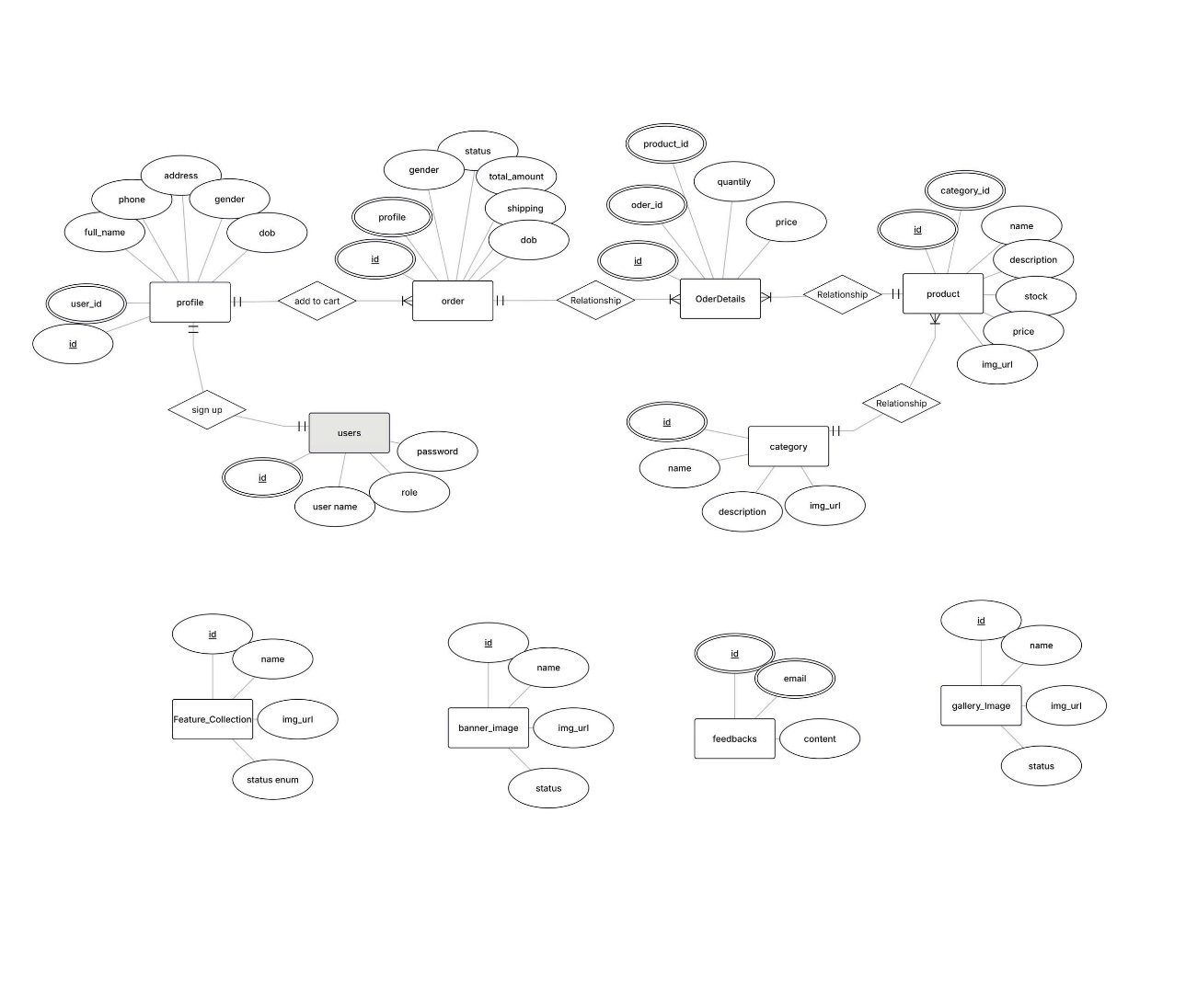
The Entity-Relationship Diagram (ERD) for the Maverick Dresses e-commerce system provides a clear and structured representation of the database, capturing the relationships between users, categories, products, orders, and other entities essential for an online apparel platform. The design ensures referential integrity, supports the system’s core functionalities such as product browsing, cart and order management, and customer feedback, while also allowing for future scalability.
By normalizing the database and defining clear relationships between entities like Users–Profiles, Categories–Products, and Orders–OrderDetails, the ERD lays a solid foundation for efficient data management and retrieval. This structure aligns with the project’s objective of delivering a seamless, secure, and reliable e-commerce experience for both administrators and customers.

Database Design
The diagram represents the database design for the Maverick Dresses e-commerce system, featuring multiple tables with defined relationships, fields, and their respective functionalities. This design captures the essential elements of an online clothing store, ensuring data integrity, consistency, and scalability.
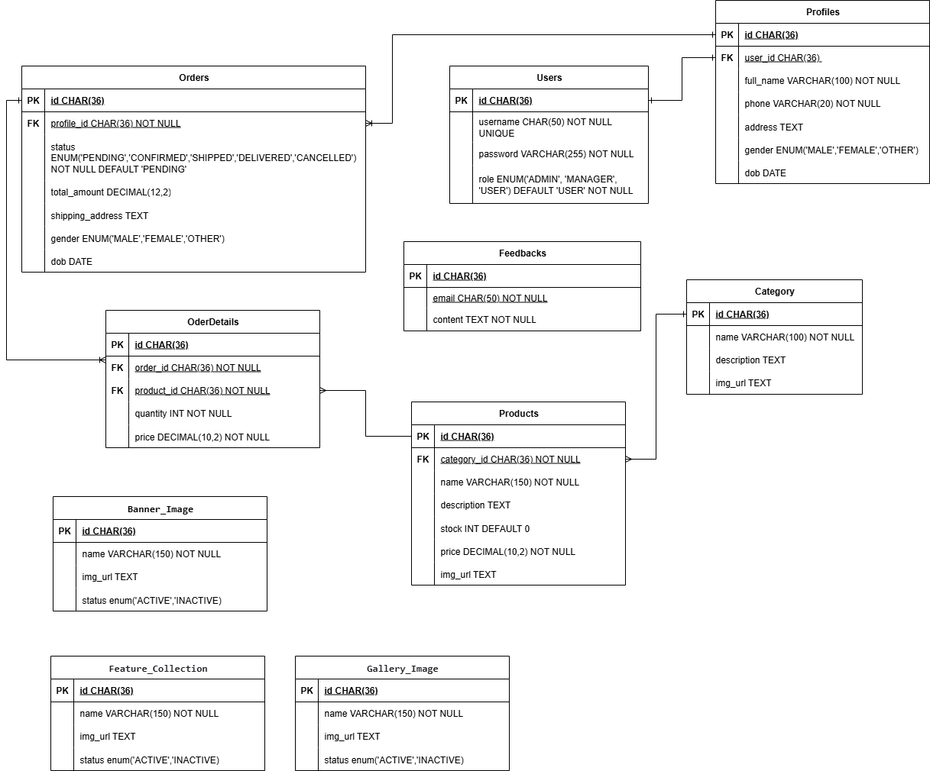

Detailed Table Descriptions
1. Users Table
Stores account information of all system users (Admin, Manager).
- Fields:
  - id (CHAR(36), Primary Key): Unique identifier for each user (UUID).
  - username (CHAR(50), UNIQUE): Stores login username.
  - password (VARCHAR(255)): Stores the hashed password.
  - role (ENUM('ADMIN','MANAGER','USER'), DEFAULT 'USER'): Defines the role.
- Indexes:
  - Unique index on username.
- Relationships:
  - One-to-one with Profiles table.
  - Referenced by Profiles.user_id.

2. Profiles Table
Stores additional personal details of users.
- Fields:
  - id (CHAR(36), Primary Key).
  - user_id (CHAR(36), Foreign Key → Users.id).
  - full_name (VARCHAR(100)).
  - phone (VARCHAR(20)).
  - address (TEXT).
  - gender (ENUM('MALE','FEMALE','OTHER')).
  - dob (DATE).
- Relationships:
  - Each profile belongs to one user.
  - Referenced by Orders.profile_id.

3. Category Table
Organizes products into logical groups (e.g., Shirts, Skirts, Frocks, Belts, Socks).
- Fields:
  - id (CHAR(36), Primary Key).
  - name (VARCHAR(100)).
  - description (TEXT).
  - img_url (TEXT).
- Relationships:
  - One-to-many with Products.

4. Products Table
Stores details of clothing products available for sale.
- Fields:
  - id (CHAR(36), Primary Key).
  - category_id (CHAR(36), Foreign Key → Category.id).
  - name (VARCHAR(150)).
  - description (TEXT).
  - stock (INT, DEFAULT 0).
  - price (DECIMAL(10,2)).
  - img_url (TEXT).
- Relationships:
  - Many products belong to one category.
  - Referenced by OrderDetails.product_id.

5. Orders Table
Represents customer purchase transactions.
- Fields:
  - id (CHAR(36), Primary Key).
  - profile_id (CHAR(36), Foreign Key → Profiles.id).
  - status (ENUM('PENDING','CONFIRMED','SHIPPED','DELIVERED','CANCELLED'), DEFAULT 'PENDING').
  - total_amount (DECIMAL(12,2)).
  - shipping_address (TEXT).
  - gender (ENUM('MALE','FEMALE','OTHER')).
  - dob (DATE).
- Relationships:
  - One profile can have many orders.
  - Referenced by OrderDetails.order_id.

6. OrderDetails Table
Stores the list of products associated with each order.
- Fields:
  - id (CHAR(36), Primary Key).
  - order_id (CHAR(36), Foreign Key → Orders.id).
  - product_id (CHAR(36), Foreign Key → Products.id).
  - quantity (INT).
  - price (DECIMAL(10,2)).
- Relationships:
  - Many-to-one with Orders.
  - Many-to-one with Products.

7. Feedbacks Table
Captures customer reviews and feedback.
- Fields:
  - id (CHAR(36), Primary Key).
  - email (CHAR(50)).
  - content (TEXT).
- Relationships:
  - Standalone, not strictly tied to Users (anyone can submit feedback).

8. Banner_Image Table
Stores banner images for promotional purposes.
- Fields:
  - id (CHAR(36), Primary Key).
  - name (VARCHAR(150)).
  - img_url (TEXT).
  - status (ENUM('ACTIVE','INACTIVE')).

9. Feature_Collection Table
Manages seasonal or special product collections.
- Fields:
  - id (CHAR(36), Primary Key).
  - name (VARCHAR(150)).
  - img_url (TEXT).
  - status (ENUM('ACTIVE','INACTIVE')).

10. Gallery_Image Table
Stores fashion gallery images (lookbooks, campaigns).
- Fields:
  - id (CHAR(36), Primary Key).
  - name (VARCHAR(150)).
  - img_url (TEXT).
  - status (ENUM('ACTIVE','INACTIVE')).

Sitemap

Site Map Overview
A site map provides a clear representation of the structure of the Maverick Dresses e-commerce website, showing how different pages are organized and interconnected. The structure is primarily derived from the navigation bar (navbar), combined with dynamic category links fetched from the database.

Textual Site Map
Top-Level Navigation (React Router)
/ → Home (wrapped in HomeLayouts)
/cart → Cart
/#category → Category Page
/product → Product
/order-confirm → Order Confirmation
/#footer → About Us (Footer Section)
/#gallery → Gallery / Lookbook
/admin/* → Admin Dashboard (protected by role)
/manager/* → Manager Dashboard (protected by role)

Inside pages/home (all wrapped in HomeLayouts)
Home.jsx (Hero Banner + Featured Products)
Cart.jsx (Shopping Cart page)
Category.jsx (Dynamic category products: Shirts, Skirts, etc.)
Product.jsx (Product detail display)
Gallery.jsx (Fashion campaigns, lookbooks)
OrderConfirm.jsx (Order confirmation after checkout)
Footer.jsx (includes About Us + Contact Info)

Dynamic Categories (fetched from DB)
Each category has its own route:
/products?category_id=

Additional Navigation Elements
Cart Icon (always visible in Navbar)
Linked to /cart.
Badge shows current number of items in cart.

2. Page Interactions and Navigation Flow
Home (Home.jsx)
- Purpose: The landing page of the website, displaying the Hero Banner, featured products, collections, and gallery highlights.
- Navigation Options:
  - Users can navigate through the navbar to Shop (Categories), Cart, About Us, and Contact.
  - The Categories dropdown (fetched dynamically from the database) links to /category/:slug.
  - The Cart Icon provides quick access to the cart with a live badge showing item count.
- Interaction: Serves as the entry point of the website. Users typically start here and move on to browse categories and products.

Shop / Category (Category.jsx)
- Purpose: The core product browsing page, showing clothing items organized by category.
- Subpages and Filters:
  - /products?category_id=id → Displays products filtered by category (e.g., Shirts, Skirts, Frocks).
  - Sorting and filtering options: by price, name, or newest arrivals.
- Navigation Options:
- Switch categories using the Categories dropdown in the navbar.
- Add products to the Cart, which updates the cart badge dynamically.
- Navigate to Cart or Checkout.
- Interaction: Users browse products, apply filters, and add items to their shopping cart.

Pages
Cart (Cart.jsx)
- Purpose: Displays the user’s shopping cart with items, quantities, and the total price.
- Navigation Options:
  - Proceed to Checkout (/order/confirm).
  - Return to Shop to continue browsing.
- Interaction: Users can update item quantities, remove products, and review their order before checkout.
Order Confirmation (OrderConfirm.jsx)
- Purpose: Confirms an order after checkout.
- Navigation Options:
  - Redirect to Home or Shop after confirmation.
- Interaction: Displays order details and a success message.

About Us (Footer.jsx)
- Purpose: Provides information about Maverick, such as mission, vision, and company background.
- Navigation Options:
- Accessible via the footer or navbar.
- Interaction: Static page, primarily informational.

Contact (Contact.jsx)
- Purpose: Allows users to submit inquiries or feedback via a contact form.
- Navigation Options:
  - Navbar links to Home, Shop, About Us, and Cart.
- Interaction: Submits messages that are stored in the Feedback table.

Gallery (Gallery.jsx)
- Purpose: Displays fashion lookbooks, seasonal collections, and promotional campaigns.
- Navigation Options:
  - Accessible from the navbar.
- Interaction: Users can browse gallery images; Admin/Manager can manage images in the dashboard.

Cart Icon
- Purpose: Quick access to the Cart page, showing the current number of products.
- Interaction:
  - Updates dynamically using React state (Context API / Redux).
  - Available on every page in the navbar.

Login (Login.jsx)
- Purpose: Provides authentication functionality for Admins and Managers to securely access the system.
- Navigation Options:
  - Accessible via the navbar “Login” link.
  - After successful authentication, users are redirected to their respective dashboards (Admin → /admin/*, Manager → /manager/*).
- Interaction:
  - Users enter email and password.
  - System validates credentials and returns a JWT token if valid.
  - On success, session state is updated and the navbar reflects the logged-in role.

Admin Dashboard (AdminDashboard.jsx)
- Purpose: Centralized dashboard for system administrators to manage users, profiles.
- Navigation Options:
  - Accessible only to authenticated Admins via /admin/*.
  - Sidebar links include: User Management, Profile Management, Dashboard Overview.
- Interaction:
  - Admins can create, update, and delete users and profiles.
  - Dashboard provides an overview of system statistics (total users, total profiles, number of Admins/Managers).
  - Admins monitor revoked tokens and maintain system security.

Manager Dashboard (ManagerDashboard.jsx)
- Purpose: Provides managers with tools to handle business operations including products, categories, orders, and promotional content.
- Navigation Options:
  - Accessible only to authenticated Managers via /manager/*.
  - Sidebar links include: Product Management, Category Management, Order Management, Banner/Gallery/Collection Management, and Reports.
- Interaction:
  - Managers perform CRUD operations on products and categories.
  - Manage orders by updating statuses (Pending, Processing, Shipped, Completed, Cancelled).
  - Upload, edit, or deactivate banners, gallery images, and featured collections.
  - View analytical charts and sales reports in the dashboard.

3. Dynamic Behavior & User Flow
Cart Updates: The cart badge updates in real time using frontend state management (Redux or Context API). Data is synchronized with the Laravel backend API.
Category Filtering: Categories are fetched dynamically from /api/products and rendered in the navbar dropdown. Clicking a category navigates to ?category_id=:slug.
Active Page Highlighting: Achieved with NavLink from react-router-dom, which automatically applies an active class.
User Session: Managed with JWT tokens stored in HttpOnly cookies. Navbar displays different options depending on whether the user is logged in and their role (Admin/Manager).

Conclusion
The site map of the Maverick Dresses e-commerce platform is carefully designed to ensure a seamless and user-friendly navigation experience. The main pages—Home, Shop, About Us, Contact, and Cart—are directly accessible from the navbar, while dropdown menus for Shop and Categories provide dynamic access to product-specific views. This structure allows users to explore products efficiently by category and navigate easily between different sections of the site.
The inclusion of features such as the Cart Icon with a dynamic badge and active page highlighting improves usability by keeping users aware of their current position and purchase progress. The navigation flow is intuitive, guiding users from browsing products to adding items to the cart and completing the checkout process.
By combining functional e-commerce workflows with informational pages like About Us and Contact, the site map strikes a balance between shopping convenience and brand communication. This structure supports both new visitors and returning customers, reinforcing Maverick Dresses’ goal of delivering an engaging and efficient online shopping experience.
Task | Start time | Finish time | Implemented by | Evaluation(%)
Project research phase
Prepare Document | 23/08/2025 | 27/08/2025 | Ha Thanh Vu | 25
Contribute ideas | 23/08/2025 | 27/08/2025 | Le Nhat Minh | 25
Contribute ideas | 23/08/2025 | 27/08/2025 | Nguyen Thanh Tam | 25
Revise and edit the content | 23/08/2025 | 27/08/2025 | Pham Tien Dat | 25
System design phase
Implement | 27/08/2025 | 05/09/2025 | Ha Thanh Vu | 60
Contribute ideas | 27/08/2025 | 05/09/2025 | Le Nhat Minh | 10
Contribute ideas | 27/08/2025 | 05/09/2025 | Nguyen Thanh Tam | 10
Implement | 27/08/2025 | 05/09/2025 | Pham Tien Dat | 20
UI/UX design phase
Design, Implement | 05/9/2025 | 07/09/2025 | Ha Thanh Vu | 45
Implement | 05/9/2025 | 07/09/2025 | Le Nhat Minh | 15
Implement, Contribute ideas | 05/9/2025 | 07/09/2025 | Nguyen Thanh Tam | 30
Contribute ideas | 05/9/2025 | 07/09/2025 | Pham Tien Dat | 10
Development phase
Design, Implement | 07/09/2025 | 19/09/2025 | Ha Thanh Vu | 60
Implement | 07/09/2025 | 19/09/2025 | Le Nhat Minh | 20
Implement | 07/09/2025 | 19/09/2025 | Nguyen Thanh Tam | 10
Implement | 07/09/2025 | 19/09/2025 | Pham Tien Dat | 10
Testing phase
Implement | 19/09/2025 | 22/09/2025 | Ha Thanh Vu | 25
Implement | 19/09/2025 | 22/09/2025 | Le Nhat Minh | 25
Implement | 19/09/2025 | 22/09/2025 | Nguyen Thanh Tam | 25
Implement | 19/09/2025 | 22/09/2025 | Pham Tien Dat | 25
Deployment phase
Implement | 22/09/2025 | 26/09/2025 | Ha Thanh Vu | 60
Support | 22/09/2025 | 26/09/2025 | Le Nhat Minh | 20
Support | 22/09/2025 | 26/09/2025 | Nguyen Thanh Tam | 20
Support | 22/09/2025 | 26/09/2025 | Pham Tien Dat | 20

Task Sheet

Detailed Explanation of the Task Sheet
The Task Sheet outlines the tasks, timelines, team member responsibilities, and evaluation percentages for an e-commerce project across six phases: Project research, System Design, UI/UX Design, Development, Testing, and Deployment. The project spans from August 23, 2025, to September 26, 2025, and involves four team members: Ha Thanh Vu, Le Nhat Minh, Pham Tien Dat, Nguyen Thanh Tam. Each phase includes tasks such as contributing ideas and revising/editing content, with specific start and finish dates and evaluation percentages reflecting each member’s contribution.
1. Overview of the Task Sheet
The Task Sheet is structured as a table with the following columns:
Task: The specific activity or responsibility (e.g., "Prepare Document," "Contribute ideas," "Revise and edit the content").
Start Time: The date when the task begins.
Finish Time: The date when the task is completed.
Implemented By: The team member responsible for the task.
Evaluation (%): The percentage of contribution or effort by the team member for that task, reflecting their involvement or responsibility.
The project is divided into six phases, each with a set of tasks assigned to the team members. The evaluation percentages indicate the relative effort or responsibility of each member for a given task, with the total percentage for each phase typically summing to 100% (or close to it, depending on the task distribution).

1. Phase-by-Phase Breakdown
The Task Sheet outlines the tasks, timelines, responsibilities, and evaluation percentages for an e-commerce project across six phases: Project Research, System Design, UI/UX Design, Development, Testing, and Deployment.
The project spans 35 days (23/08/2025 – 26/09/2025) and involves four members: Ha Thanh Vu, Le Nhat Minh, Nguyen Thanh Tam, and Pham Tien Dat. Each phase includes specific tasks such as preparing documents, implementing features, contributing ideas, or editing content. The evaluation percentages reflect each member’s level of responsibility.

1. Project Research Phase (23/08/2025 – 27/08/2025)

Prepare Document – Ha Thanh Vu (25%)
Contribute Ideas – Le Nhat Minh (25%), Nguyen Thanh Tam (25%)
Revise and Edit Content – Pham Tien Dat (25%)
Description: Initial research and documentation, with contributions in idea generation and refinement.
✅ Total Evaluation = 100%

2. System Design Phase (27/08/2025 – 05/09/2025)

Implement – Ha Thanh Vu (60%), Pham Tien Dat (20%)
Contribute Ideas – Le Nhat Minh (10%), Nguyen Thanh Tam (10%)
Description: Designed the system architecture, provided input on design ideas, and finalized documentation.
✅ Total Evaluation = 100%

3. UI/UX Design Phase (05/09/2025 – 07/09/2025)

Design & Implement – Ha Thanh Vu (45%)
Implement – Le Nhat Minh (15%)
Implement & Contribute Ideas – Nguyen Thanh Tam (30%)
Contribute Ideas – Pham Tien Dat (10%)
Description: Developed and refined UI/UX designs, ensuring consistency and usability.
✅ Total Evaluation = 100%

4. Development Phase (07/09/2025 – 19/09/2025)

Design & Implement – Ha Thanh Vu (60%)
Implement – Le Nhat Minh (20%), Nguyen Thanh Tam (10%), Pham Tien Dat (10%)
Description: Implemented the main system features, with majority contribution from Ha Thanh Vu.
✅ Total Evaluation = 100%

5. Testing Phase (19/09/2025 – 22/09/2025)

Implement (Testing) – Ha Thanh Vu (25%), Le Nhat Minh (25%), Nguyen Thanh Tam (25%), Pham Tien Dat (25%)
Description: Conducted system testing, identified issues, and ensured fixes were properly validated.
✅ Total Evaluation = 100%

6. Deployment Phase (22/09/2025 – 26/09/2025)

Implement (Deployment) – Ha Thanh Vu (70%)
Support – Le Nhat Minh (10%), Nguyen Thanh Tam (10%), Pham Tien Dat (10%)
Description: Deployed the system to production with supporting contributions in configuration and documentation.
✅ Total Evaluation = 100%

2. Analysis and Insights
Team Roles
Ha Thanh Vu plays the most critical role across all phases, taking primary responsibility for preparing documents, designing, and implementing key system features. His contributions are highest in the System Design (60%), Development (60%), and Deployment (70%) phases, showing his role as the technical leader of the project.
Le Nhat Minh provides consistent support throughout the project, contributing mainly in idea generation (25% in Research phase) and later in implementation and support tasks (10–25%), reflecting steady involvement in both planning and execution.
Nguyen Thanh Tam contributes significantly in the UI/UX Design phase (30%) and participates in all other phases (10–25%), showing strong involvement in both design and implementation.
Pham Tien Dat is responsible for editing and content refinement in the Research phase (25%) and provides steady contributions (10–20%) during design, development, testing, and deployment, ensuring quality and consistency.

Timeline Efficiency
The project runs for 35 days (23/08/2025 – 26/09/2025).
The Development phase (07/09 – 19/09, 13 days) and System Design phase (27/08 – 05/09, 10 days) are the longest, reflecting the complexity of system architecture and coding.
The UI/UX Design phase (3 days), Testing phase (4 days), and Deployment phase (5 days) are relatively short, which may indicate a need for extended time to ensure high-quality outcomes and stable deployment.

Evaluation Distribution
The evaluation percentages in each phase sum to 100%, ensuring balanced task distribution.
Development and Deployment phases show clear leadership by Ha Thanh Vu with major contributions (60–70%), while other members support with smaller shares.
In contrast, the Testing phase has an even distribution (25% each), reflecting full team collaboration and equal participation.

Conclusion
The Maverick Dresses project represents a significant milestone in our academic journey at Aptech, combining theoretical knowledge with practical application to build a fully functional e-commerce platform for the apparel industry. Over the course of development, our team successfully delivered a system that modernizes traditional retail operations by providing customers with an intuitive, engaging, and reliable online shopping experience.
The project achieved its primary objectives by implementing key e-commerce functionalities, including dynamic product categorization, cart and order management, banner and gallery displays, role-based administration, and customer feedback submission. Through these features, Maverick Dresses addresses the limitations of physical-only retail and demonstrates the transformative potential of digital commerce.
Throughout this project, we gained valuable experience in structured software development, following distinct phases of feasibility analysis, requirements gathering, system design, coding, testing, and deployment. Challenges such as adapting to unfamiliar technologies, working under tight deadlines, and ensuring system security pushed us to collaborate effectively, learn rapidly, and apply best practices. The use of modern tools—including Laravel for backend services, React for the frontend, MySQL for data management, and JWT for secure authentication—further enhanced our technical proficiency.
The system as it stands fulfills its functional and non-functional requirements, ensuring usability, reliability, and data security. Nonetheless, we recognize opportunities for improvement, such as implementing a responsive design, expanding payment methods, integrating real-time inventory synchronization, and introducing advanced features like AI-powered product recommendations, live chat, and multi-language support. These enhancements, while beyond the scope of this academic project, are feasible due to the solid modular foundation of our current system.
In conclusion, the Maverick Dresses project has been both academically enriching and professionally rewarding. It strengthened our technical skills, teamwork, and problem-solving abilities, while also preparing us for the challenges of real-world software development. We are grateful to our mentor, Mr. To Hoang Anh, for his guidance and constructive feedback, and to Aptech for providing the environment and resources to undertake this endeavor. Most importantly, we take pride in the collaborative effort of our team, whose dedication and persistence brought this project to life. Moving forward, we are confident that the knowledge and experience gained from Maverick Dresses will serve as a strong foundation for our future careers in software engineering.

